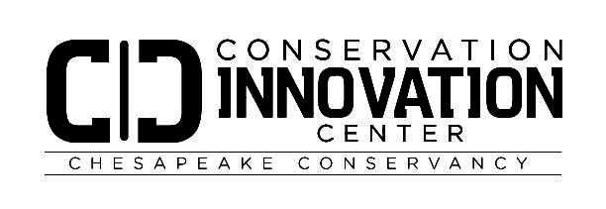
Natural Resource and Conservation Mapping and Management Internship
The Chesapeake Conservancy’s Conservation Innovation Center (CIC) in partnership with the Bureau of Land Management (BLM) is pleased to offer two 10-week summer internships focused on developing knowledge in the use of geographic information systems (GIS) for managing natural resource areas for conservation purposes. Interns will gain technical skills in ESRI ArcGIS software to map recreational resources and environmental conditions of BLM lands in Southern Maryland while gaining insights into remote sensing, land use classification, climate resilience, and recreation resource planning. In addition to GIS technology, students will engage with natural resource and conservation professionals to learn how mapping supports planning, policy development, conservation decision making, resource restoration, and equitable access to recreational resources in these career areas. These internships are conducted in a hybrid work environment with 70% of the work completed virtually and the remaining 30% at the Conservancy’s Annapolis-based office with some limited field time at the BLM Douglas Point Special Recreation Management Area in Charles County, MD. Internships will culminate with presentation of original maps and an environmental condition assessment report in a brief webinar format and web-based story maps. Students will work 15-25 hours per week under the supervision of a Chesapeake Conservancy intern advisor, a $20/hour stipend will be provided.

Qualifications:
- Interest in learning Geographic Information Systems, course work in GIS preferred but not required.
- Completion of 2 years of academic work in pursuit of degrees in Landscape Architecture, Computer and Information Sciences, Recreation, or Biological Sciences preferred, other degree areas considered in consultation with the applicant.
- The ability to learn and apply new software skills.
- Access to reliable internet for remote work is required.
- Good oral and written communication skills and the ability to follow oral and written directions.
- Interest in resource conservation, resource planning, policy or communications preferred.
- Authorization to work in the United States is required.
- All Chesapeake Conservancy employees are required to be fully vaccinated for COVID-19
Expected Dates: June 5, 2023 – August 10, 2023

Contact: Steve Storck, CIC Internship Coordinator, at sstorck@chesapeakeconservancy.org

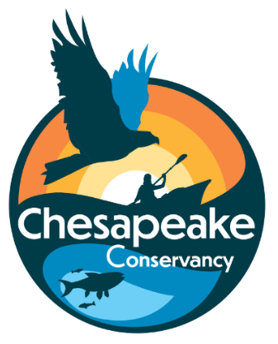
ABOUT THE CONSERVANCY
Chesapeake Conservancy is a nonprofit organization based in Annapolis, Maryland, dedicated to ensuring a healthier Chesapeake Bay watershed where fish and wildlife thrive, with healthy waters and abundant forests, wetlands, shorelines, and open spaces. With the human population in the Chesapeake Bay watershed approaching 18 million and growing, and with tens of thousands of acres of open space vanishing each year, the Conservancy works to connect people with the Chesapeake’s wildlife and history, conserve landscapes and rivers, and restore the region’s natural resources. The Conservancy works in close partnership with the Environmental Protection Agency Chesapeake Bay Program, National Park Service Chesapeake Bay Office, the United States Fish and Wildlife Service, the Bureau of Land Management, as well as other federal, state, and local agencies, private foundations, and corporations to advance conservation.

Within the Conservancy, the Conservation Innovation Center (CIC) has become a globally recognized leader in producing data, analyses, and web applications to advance precision conservation and restoration. Through collaborative partnerships, CIC develops innovative custom approaches to leverage high-resolution geospatial data to support informed decision making. CIC works with leading technical organizations like ESRI and Microsoft to deliver more precise data and bring cutting edge technology and techniques to our work. More information is available on our website at https://www.chesapeakeconservancy.org/conservation-innovation-center/

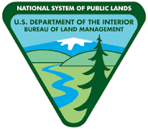
The Bureau of Land Management was established in 1946 with a mission to sustain the health, diversity, and productivity of public lands for the use and enjoyment of present and future generations. The agency, a division of the US Department of the Interior, manages over 230 million acres of public lands throughout the United States including 25 national monuments, 21 national conservation areas and 8.8 million acres of designated wilderness. The Eastern States unit of BLM manages over 40,000 acres in 31 states east of the Mississippi River with a focus on outdoor recreation, stewardship, energy production and resource management. The Douglas Point Special Recreation Area is a unique partnership between Federal and State resource agencies jointly managed by BLM and the Maryland Department of Natural Resources. This 1270-acre site is part of the Nanjemoy Natural Resource Management Area (NRMA) and represents one of the last remaining undeveloped tracts along the Potomac River. Douglas Point encompasses 548 acres of hardwood forest and marshes, picnic area overlook, river shoreline, an accessible historical walk, and hunting blinds. For more information on the Eastern States BLM unit please visit https://www.blm.gov/eastern-states.

WE ARE COMMITTED TO BEING A DIVERSE & WELCOMING WORKPLACE:
Chesapeake Conservancy is an equal opportunity employer. We do not discriminate on the basis of race, religion, national origin, color, age, sex, disability, veteran status, sexual orientation, genetic information, gender identity, refusal to submit to a genetic test or to make available genetic test results, or any other legally protected characteristic. Chesapeake Conservancy understands that protecting and restoring the natural and cultural resources of the Chesapeake Bay watershed requires intentional commitment to inclusive practices and narratives within the conservation movement. Through our work we celebrate and elevate the people, places, and cultures of the region, especially by engaging underrepresented communities. Committing to the values of Diversity, Equity, Inclusion, and Justice is critical to achieve our vision of a Chesapeake that is healthy, accessible to everyone, and a place where people and wildlife thrive. To that end, we commit ourselves to Diversity, Equity, Inclusion, and Justice both in our programmatic priorities and our internal organizational development through inclusive recruitment of staff and board members and fostering a diverse and inclusive culture.

