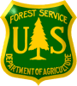

USDA Forest Service -R2 Rocky Mountain Region
Grand Mesa, Uncompahgre and Gunnison NF

Grand Junction or Paonia Colorado
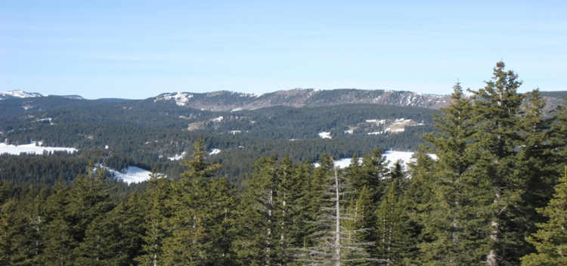

Lead Forestry Technician - Timber Sale Preparation

** Pathways Recent Graduate Program **
GS – 0462 –04/05/06/07

Position: The Grand Mesa, Uncompahgre and Gunnison (GMUG) National Forest located in Western Colorado has identified a Pathways Recent Graduate opportunity. This permanent position is located at either the Grand Valley RD Office in Grand Junction, Colorado or the Paonia RD Office in Paonia, CO. This position is being advertised through Society of American Foresters in a virtual hiring event November 3-6th 2021. The group announcements for these positions will also be open on USAJOBS November 3-9th 2021. Applicants do not need to be at the conference to apply. This outreach notice is being circulated to inform prospective applicants of the upcoming opportunity.

For more information on the SAF Hiring Event go to the website:

https://www.fs.fed.us/forestmanagement/recruitment_saf/index.shtml

Major Duties: The duties of this position consist of managing and supervising the preparation of commercial timber sales on the Grand Valley Ranger District.

The successful candidate will Lead a team of employees performing work up to the GS-05 level. Responsible for identifying, distributing, and balancing the workload and tasks among employees in accordance with established workflow and skill level. Establishes priorities to ensure timely accomplishment of assigned team tasks. Monitors and reports on the status and progress of work. Instructs employees in specific tasks and job techniques and provides on the job training to new employees. Answers questions on procedures, policies, and directives and obtains needed information or decisions from supervisor on problems that occur. Checks on work in progress. Approves leave for a few hours or for emergencies. Resolves simple, informal complaints of employees and refers others to the supervisor. Reports to the supervisor on performance, progress, and training needs.

The incumbent leads a small marking crew performing a variety of timber sale preparation (TSP) duties that include—but not limited to—timber marking, timber cruising, and sale layout as part of the unit’s timber management program. Estimates volume, defect, and quality of timber in a given area. Measures and defects timber on the ground using maps and written cruise plans provided by an advanced cruiser that explain sampling intensity, plot locations, type of cruise and any special instructions. Under supervision of a professional forester, and using pre-established marking rules, selects and marks trees to be harvested or left uncut. Prepares area maps and marks boundaries. Summarizes cruising and marking data and prepares reports. Provides technical assistance to specialists in the development of complex logging plans and preliminary road location. Performs other multifunctional work, as assigned, in other areas of resource management such as wildlife, recreation, visuals, resource planning, and fire management. Performs other resource or fire duties as qualified and assigned.

What we are looking for in a Candidate: We are looking for enthusiastic, self-motivated, outdoor-oriented person to join our team. The physical setting is stunning and the work is diverse and challenging. To be successful in this job you must be a self-starter and have the ability to adjust in an ever-changing environment. You must be willing to take on challenges and provide innovative solutions to complex problems. Candidates must have excellent communication skills and be able to work collaboratively with external partners and be a contributing member to a team of dynamic and creative leaders.

About the GMUG Forest: The GMUG National Forest encompasses 5,000 square miles on the Western Slope of the Colorado Rockies, about 250 miles west of Denver, in west-central Colorado. This forest has five Ranger Districts: Grand Valley with offices in Collbran and Grand Junction, Paonia office is located in Paonia, Gunnison office is located in Gunnison, Ouray office is located in Montrose, and Norwood office is located in Norwood. The Supervisor's Office is located in Delta, Colorado.

The GMUG NFS contain 3,163,131 acres with some of the most spectacular scenery in the Rockies with elevations ranging from 6,000 feet to over 14,000 feet. The climate at lower elevations is warm and arid while the high country is cold in the winter and warm most of the summer months. The Forest is an ideal winter and summer recreation area. The Forest has three ski areas, 43 communities, and a 12,000 square mile area of influence that includes a 250,000 population. Cost of living is one of the lowest in the country in lower elevations and among the highest in the country near the ski areas. For additional forest information, visit the internal website: http://fsweb.gmug.r2.fs.fed.us/ and external web site: http://www.fs.usda.gov/GMUG.

Community Information: Grand Junction is the largest Community in Mesa County. It’s located at the junction of the Gunnison and the Colorado rivers. Grand Junction is home to approximately 56,446 residents, and Mesa County has a population of approximately 147,522. Mesa County has about 3,313 square miles of land and Grand Junction is on 27 of those square miles. Two-thirds of the land is owned by the Federal Government and offers a great variety of outdoor recreation and entertainment.

Grand Junction is a wonderful place to visit and even a better place to live. With more than two thirds of the surrounding county owned by the federal government, outdoor recreation and enjoyment is a favorite pastime of local residents during the daytime. Evenings bring a variety of entertainment venues in several commercial regions of the city, including our award-winning downtown area. Grand Junction is about 42 miles north of Delta on Hwy. 50; which is where the SO Office is located.

There are 4 hospitals, with the Grand Junction VA Hospital being one of them. There is also an airport that offers many different flights to accommodate for easy traveling. For additional information on Grand Junction and the surrounding areas, please visit the Chamber of Commerce website at http://www.gjchamber.org/index.asp. You may also want to visit http://grandjunction.org/ or www.colorado.com/cities-and-towns/grand-junction.

Paonia is a town located in Delta County, and is located in the headwaters of the North Fork of the Gunnison River. It is home to approximately 1,500 residents. Another 5,000 residents can be found in surrounding areas. Delta, the nearest larger town is approximately 30 miles west on Hwy 133 with the county having a population of approximately 26,700 people. Hotchkiss the next small town approximately 10 miles west of Paonia on Hwy 133, have a Supermarket Chain and Dollar Store. There are 22 churches in Paonia and most faiths are located within a 20-mile radius. The next 2 closest cities are Montrose which is 39 miles from Paonia (21 miles south of Delta on Hwy 50), and Grand Junction that is 60 miles from Paonia (42 miles north of Delta on Hwy 50). Paonia has an elevation of approximately 5600 feet. The average family home is $233,000 with rent ranging between $700 and $1,000 a month.

Paonia is a great place to visit and a wonderful place to live. The Paonia Ranger District is primarily a recreation and range district with signification mineral potential within the Gunnison National Forest; it has a staff of 12 full time employees and 3-4 seasonal employees that provides management and services with an annual budget of approximately $600,000. Vegetation and topography are typical of higher elevation Rocky Mountains. Elevations on the District range from 8,500 to 12,000 feet. Both the northern and southern portions of the District are dominated by large mesas with gently rolling topography It is a small, rural agricultural community, and one can obtain the "necessities of life" in the town itself.

The climate is exceptional with warm summer temperatures in the 80-90s, accompanied by a cool breeze every evening. Autumn is crowned with beautiful colors with winter temperatures averaging a low of 24 degrees. The average annual rainfall is about 14 inches and snowfall is about 50 inches. For additional information we suggest contacting the Commerce at P.O. Box 366, Paonia, CO 81428, http://www.paoniachamber.com or (970) 527-3886 for further information regarding the area

Responding to Outreach: If you are interested in this position, and have questions about the job or the communities please contact Cari Johnson @ 403 E Rio Grande Ave, Paonia, CO 81428; fax to 970-527-4151; e-mail to cari.johnson@usda/.gov or you may contact her at (970) 527-4131 for specific questions of the position.

Thank you for your interest!

